**Problem 1**

Write NEGATION of the following statements (**Careful, NEGATION is not the same as INVERSE**)

1. If P is a square, then P is a rectangle.
2. If n is prime, then n is odd or n is 2.
3. If Aangloo is Meena's father, then Baangloo is her uncle and Bingli is her Aunt.
4. A positive integer is prime only if it has no divisors other than 1 and itself.
5. Being divisible by 3 is a necessary condition for this number to be divisible by 9.

**Negation:**

1. $P$ is a square and it is not a rectangle.
2. $n$ is prime and $n$ is not odd and $n$ is not 2.
3. Angloo is Meena’s father and Bangloo is not her uncle OR Bingli is not her aunt.
4. A positive integer is prime and it has divisor other 1 or itself.
5. A number is divisible by 9 and it is not divisible by 3.

**Problem 2**

Part 1: Write CONVERSE of the following statements.

1. If P is a square, then P is a rectangle.
2. If n is prime, then n is odd or n is 2.
3. If Aangloo is Meena's father, then Baangloo is her uncle and Bingli is her Aunt.
4. A positive integer is prime only if it has no divisors other than 1 and itself.
5. Being divisible by 3 is a necessary condition for this number to be divisible by 9.

**Converse:**

1. If $P$ is a rectangle, then $P$ is a square.
2. If $n$ is odd or $n$ is 2, then $n$ is prime.
3. If Baangloo is her uncle and Bingli is her Aunt, then Aangloo is Meena's father.
4. If a number has no divisor other than 1 and itself, then it is a prime number.
5. Being divisible by 9 is a necessary condition for the number to be divisible by 3

(or we may write… If a number is divisible by 3, then it is divisible by 9)

Part 2: Write CONTRPOSITIVE of the following statements.

1. If P is a square, then P is a rectangle.
2. If n is prime, then n is odd or n is 2.
3. If Aangloo is Meena's father, then Baangloo is her uncle and Bingli is her Aunt.
4. A positive integer is prime only if it has no divisors other than 1 and itself.
5. Being divisible by 3 is a necessary condition for this number to be divisible by 9.

**Contrapositive:**

1. If $P$ is not a rectangle, then $P$ is not a square.
2. If $n$ is not odd and $n$ is not 2, then $n$ is not prime.
3. If Baangloo is nor her uncle OR Bingli is not her Aunt, then Aangloo is not Meena's father.
4. If a number has divisor other than 1 or itself, then it is a not prime number.
5. Being not divisible by 9 is a necessary condition for the number to be not divisible by 3.

(or we may write… If a number is not divisible by 3, then it is not divisible by 9)

Part 3: Construct a truth table for each of these compound propositions.

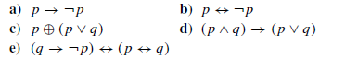

|  |  |  |
| --- | --- | --- |
| $$p$$ | $$¬p$$ | $$p→¬p$$ |
| **0** | **1** | **1** |
| **1** | **0** | **0** |

|  |  |  |
| --- | --- | --- |
|  |  |  |
| **0** | **1** | **0** |
| **1** | **0** | **0** |

|  |  |  |  |
| --- | --- | --- | --- |
|  |  |  |  |
| **0** | **0** | **0** | **0** |
| **0** | **1** | **1** | **1** |
| **1** | **0** | **1** | **0** |
| **1** | **1** | **1** | **0** |



|  |  |  |  |  |
| --- | --- | --- | --- | --- |
|  |  |  |  |  |
| **0** | **0** | **0** | **0** | **1** |
| **0** | **1** | **0** | **1** | **1** |
| **1** | **0** | **0** | **1** | **1** |
| **1** | **1** | **1** | **1** | **1** |



|  |  |  |  |  |  |
| --- | --- | --- | --- | --- | --- |
|  |  |  |  |  |  |
| **0** | **0** | **1** | **1** | **1** | **1** |
| **0** | **1** | **1** | **1** | **0** | **0** |
| **1** | **0** | **0** | **1** | **0** | **0** |
| **1** | **1** | **0** | **0** | **1** | **0** |

**Problem 3**

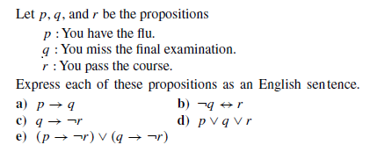

1. **If you have flu then you you miss the final exam.**
2. **You do not miss the final exam if and only if you pass the course.**
3. **If you miss the final exam then you do not pass the course.**
4. **You have the flu or you miss the final exam or you pass the course.**
5. **If you have the flu then you do not pass the course or if you miss the final exam then you do not pass the course.**

**Problem 4**

Part 1: Express the following statements using quantifiers, variables, and the predicates, with following information:

$D$ is set of all students

$M\left(s\right):$ $s$ is a math major student

$C\left(s\right):$ $s$ is a computer science major student

$E\left(s\right):$ $s$ is an engineering major student

1. There is an engineering student who is a math major.

$∃s∈D$ such that $E\left(s\right)∧M\left(s\right)$

1. Every computer science student is an engineering student.
$$∀s∈D, C\left(s\right)→E\left(s\right)$$

2. No computer science students are engineering student.

$∀s∈D$ such that $C\left(s\right)∧¬E\left(s\right)$

OR $∀s∈D$ such that $¬\left( C\left(s\right)→E\left(s\right) \right)$

1. Some computer science students are also math majors.

$∃s∈D$ such that $C\left(s\right)∧M\left(s\right)$

1. Some computer science students are engineering students and some are not.

$∃s∈D$ such that C $\left(s\right)∧¬E\left(s\right)$.

OR $∃s∈D$ such that C $\left(s\right)∧E\left(s\right)$

Part 2: Translate each of these nested quantifications into an English statement that expresses a mathematical fact. The domain in each case consists of all real numbers.

**a) $∃x ∀y (xy = y)$**

There is a number if multiplied to any other number, we get the other number back.

**In other words:** there exist multiplicative identity.

(Such integer is 1)

**b) $∀x ∀y ( ( (x < 0) ∧ (y < 0) ) → (xy > 0) )$**

Product of any two negative integers is positive

**c) $∃x ∃y ( (x2 > y) ∧ (x < y) )$**

Some numbers are less than certain number, but their square is greater than that particular number.

**OR in other words:**

There are such pair of numbers that square of one number is greater than the other, however the number is less than the other.

(negative numbers are such numbers)

**d) $∀x ∀y ∃z (x + y = z)$**

Sum of any two real number is a real number

(closure property of real number set)

Part 3: Rewrite each of these statements so that negations appear only within predicates (that is, so that no negation is outside a quantifier or an expression involving logical connectives).

**a) $￢∃y ∃x P(x, y)$**

$∀y∀x ¬ P(x, y)$

**b) $￢∀x ∃y P(x, y)$**

$$∃x∀y ¬P(x, y)$$

**c) $￢∃y ( Q(y) ∧ ∀x￢R(x, y) )$**

$∀y(¬Q\left(y\right)∨∃xR(x, y))$

**d) $￢∃y ( ∃x R(x, y) ∨ ∀x S(x, y) )$**

$$∀y(∀x ¬R\left(x, y\right)∧∃x ¬S(x, y))$$

**e) $￢∃y (∀x ∃z T (x, y, z) ∨ ∃x ∀z U(x, y, z) )$**

$∀y(∃x∀z ¬T \left(x, y, z\right)∧∀x∃z ¬ U(x, y, z))$

**Problem 5**

Part 1: **Give a direct proof of the following:**

1. If $k$ is an odd integer and $m$ is even, then $k^{2} + m^{2}$ is odd.

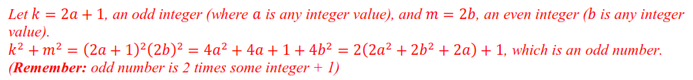

1. For any integer $n$, $n^{2}+3n+2$ is not a prime.



1. Any product of four consecutive integers is one less than a perfect square.(Hint: Take four consecutive integers as $m, m+1, m+2, m+3$)

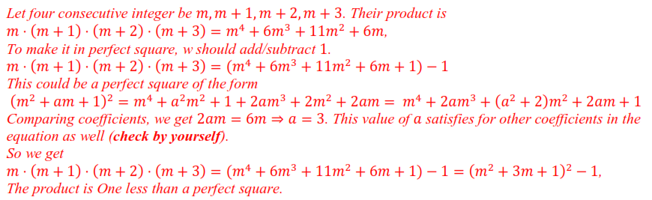

1. $n^{2}-n+3$ is odd. (**Hint:** *consider 2 cases: i) if $n$ is even, ii) if $n$ is odd, and then chenck whether the given expression is even or odd*)

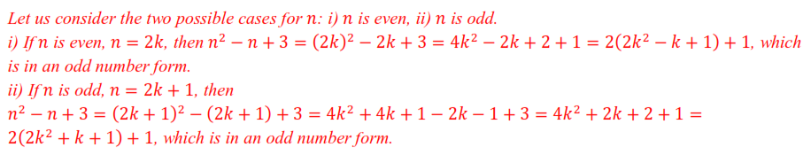

Part 2: **Give counter-examples of the following claims to dis-prove these:**

1. For all integers $n$, $n^{2}-n+11$ is a prime number.



1. For any integer $n>1$, $2^{n}-1$ is prime.



1. For all prime numbers $p$, $2^{p}-1$ is prime number. (*Such prime numbers are called Mersenne primes*)



Part 3: **Prove the following using contraposition:**

1. If $x$ and $y$ are both odd, then $x+y$ is even. (**Be careful:** *You are asked to prove by Contraposition, although Direct Proof is easier.*)

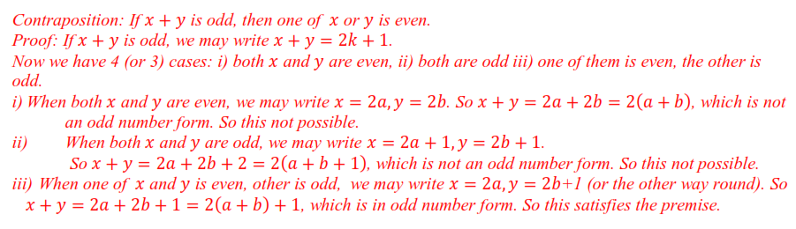

1. If $r$ is irrational, then $\sqrt{r}$ is irrational.

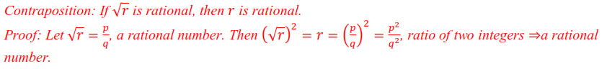

1. If $n^{2}$ is a multiple of 3, then $n$ is a multiple of 3.

